A Montgomery College Shuttle bus will be available from the Bonifant Street Parking Garage. The S indicates where the shuttle bus stops. There will be three buses running all day picking up riders at this stop and stopping at the HC Building as shown above. It also stops at the ST building which is a short walk to HC. If you are coming from the ST building side of campus, just go to the 2nd floor of ST and walk across the bridge over the metro tracks to the HC building. Riders will not need I.D. and the drivers will be informed of the conference and possible riders.
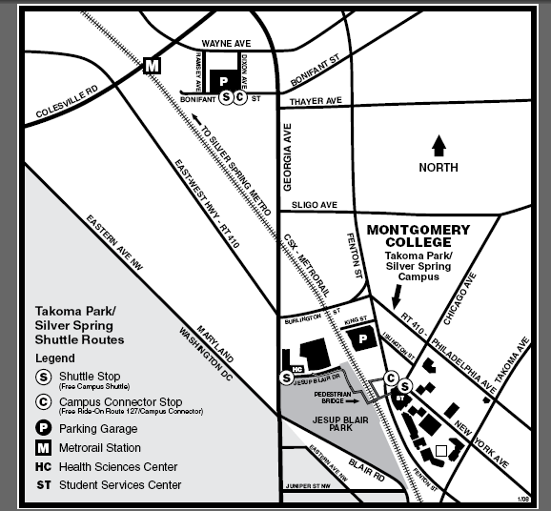

If you take the Metro to Silver Spring (Red Line), there is also public transportation that goes to the campus. At the Silver Spring Metro the Ride On Bus # 17 stops at the campus at Philadelphia and Takoma Avenue. It is a short walk to the HC Building.
You can also take the regular Metro bus F4 or F6 which also stops at Philadelphia and Takoma Avenues.

From the Takoma Park Metro there is the Ride On Bus #18 that also stops at the campus on Fenton Street.

Please note: For people interested in a brisk morning walk —this building is within walking distance to the metro.

More information and directions to Takoma Park/Silver Spring campus:

http://www.montgomerycollege.edu/maps/tpvic.html

Accommodations:

http://www.silverspringcenter.com/lodging.htm

